ASSIGNMENT(SE)

MODULE-1(SDLC)

1.What is software?what is software engineering?

* Software is a collection of instruction,information and data.
* Also we can say the collection of programs.
* It is logical component of computer,which cannot touch.
* It includes different types of Software.
* there are as follow:

->(1) System Software

->(2) Application Software ->(3) Programming Software

Software Engineering:

* Software Engineering is the learn about software that is, its how works , which component was used in made of Software. which recommendation for Software making.
* it gives knowledge about basic things which require to know before becoming or learning any course which relates to software.
* It learn ablut basic fundamental to require for becoming any Software enginner.
* In that learn or creating small or single web page.
* It is imporant thing to knoe all the IT or COMPUTER Engineering.

2.Explain Types of Software.

-There are types of Software:

1. System Software
2. Application Software
3. Pragramming Software

(i) System Software:

* System Software is designed to operate the hardware of computer.
* It also provide the platform for running Application software.

(a) Operating System:

- It is the interaction between the hardware and software. Ex:windows-Xp,linux,dos,etc..

(ii) Application Software:

* Application software is designed to perform specific user application or we can say the specific purpose.
* there are 3 types of application software:

1. Desktop Application
2. Mobile Application
3. Web Application

(a) Desktop Application:

* they works only laptop,computers.
* Ex:Microsoft office,oracle

(b) Mobile Application:

* It only works on mobile.
* Ex:Instagram,facebook,whatsapp,twitter,etc.

(c) Web Application

* they works on only web browser which is in both mobile and computers.
* Web browser is the platform where websites are run.
* Ex: Chrome ,Mozila firefox , edge ,etc.

(iii) Programming Application:

* It is Application where programe is execute.
* Ex: Compiler,Interpreter

Compiler: It is the Software which execute all lines of programe than after shows the errors.

Interpreter : It is the programming software which execute the programe line to line when it found error

than it stop that line not run after the error is not clear.

3. What is SDLC ? Explain each phase of SDLC.

* SDLC is the methodology for creating high-quality software.
* Software Development Life Cycle(SDLC) is systematic process by software developer to design a software .

that processes such as planning,analysis,design,implementation,testing,maintenance.

(i) Planning :

* It is the initial phase of SDLC.
* To create a software first we need to know what is the requirement of customer or client.

and than after we gathering the requirement of customer and than planning the software that how it look

* This includes the scope,obejectives,budget,timeline,etc.

(ii) Analysis :

* In this phase involves the understanding about end-user needs and analysis of all requirement of customer.
* Analysisabout market strategy which software or product is moving faster.

(iii) Design :

* In this phase the developer create a system architecture and base on that designed it.
* It involves the all basic of data structure that not affect the software.
* the software is design as the customeer requirement.

(iv) Implementation :

* In this phase , the developer create a code that software occurs.
* developer write a code than test the writing code that know the the code is perfectly fit on the their design or not.

(v) Testing :

* In this phase, The software tested for bugs , errors , overloading and other issues.
* different testing method are used. e.g., unit testing,integration testing,system testing,etc.

(vi) Maintenance :

* After all phase will complete than it is enter. this phase involves the ongoing support , updates , solution of bugs or some error after some time will pass.
* It ensure that the software will reliable and up to date.

4. What is DFD ? create DFD diagram on Flipkart.

* DFD that means Data Flow Diagram.
* DFD is the graphical representation of how data flows within the system. for ex. data where store, data sources.
* creating a DFD that require elements:
* External Entity
* Process
* Data flow
* Data store

External Entity : It represent the which outside entity interact with it.

Process : process on which are the incoming data and produce the output.

Data Flow : It shows the movements of data between the processes , data store and external entity.

Data Store : It is the database where data stores within the system.

5. What is Flow Chart ? create a flow chart to make a addition of two numbers.

* Flow chart is a graphical representation of a algorithm.
* Non Software engineer is make or understand the algorithm using the flowchart.
* It also called as graphical representation of data during process.
* Flow chart has some symbol for representation of algorithm such as start,process,flow,condition,pageup,Input or Output
* It is helpful in understanding of some situation like logic is complicated and problem is lengthy.
* Once flowchart is drawn than after that is easy for writing a program.

Start : there is oval symbol for represent the start and end.

Flow : there is a arrow symbol for represent the flow of data.

Condition : There is diamond symbol to represent the condition.

Process : There is rectangle symbol for represent the process during the program.

Pageup : For representing of continuous page there is a oval symbol is used.

6. What is Use case diagram ? create a use case on bill payment od paytm.

* Use case diagram is that the graphical representation of what customer or website has to access the the data or we can say what process can access by the some other such as user,website,etc.
* A use case focus on the functionality of system.



**START**

INPUT N1,N2

SUM = N1 + N2

PRINT SUM

END



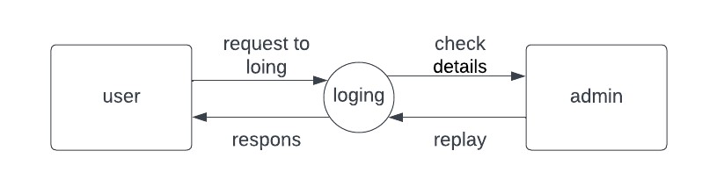

Level 0

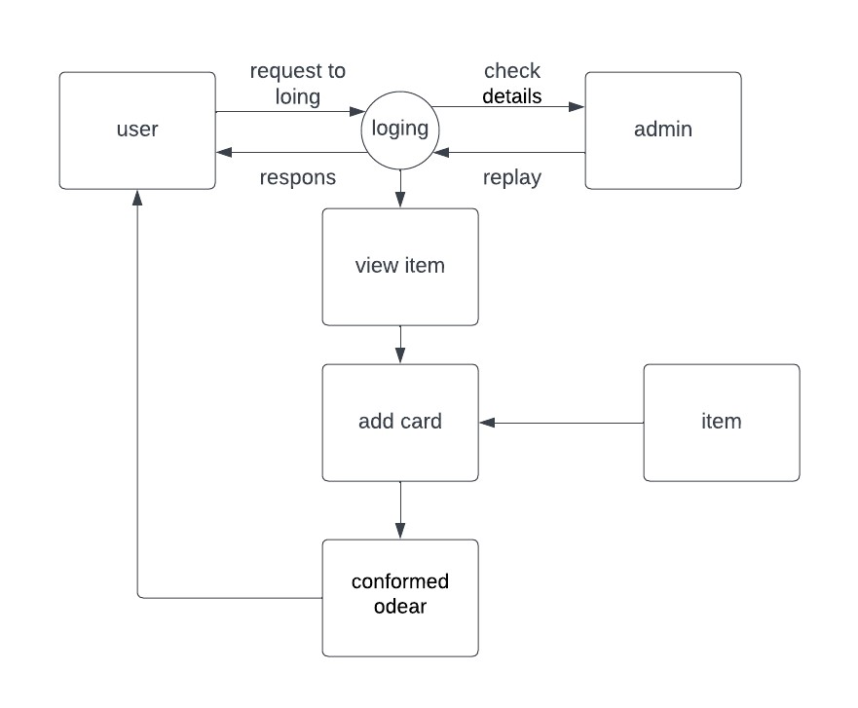

Level 1

